**Angular animations**

**Specifically, the following adjustments are required:**

* You probably need to install the **new animations package** (running the command never hurts): npm install --save @angular/animations
* Add the BrowserAnimationsModule  to your imports[]  array in **AppModule**
* This Module needs to be imported from @angular/platform-browser/animations'  => import { BrowserAnimationsModule } from '@angular/platform-browser/animations'  (in the **AppModule**!)
* You then import trigger , state , style  etc from @angular/animations  **instead of** @angular/core

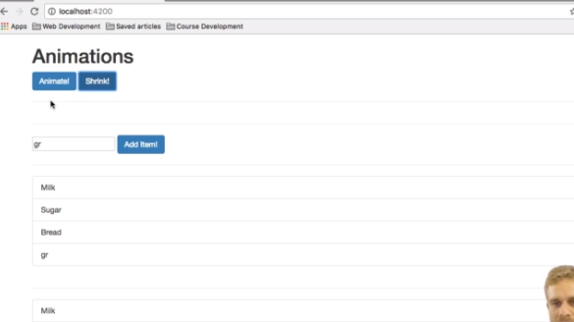

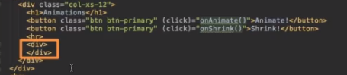

**Animations Triggers and State**

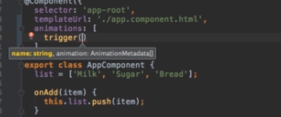

**The "void" State**

